Name:_____________________________________ Section: ________ TA: Celeste / Sarah / Ken

ATM S 101 HOMEWORK 1. Winter 2004
Due Thursday 22nd in class.

Answer in the spaces provided. Include working where appropriate, not just the numerical answers.

1. Assume that Lake Washington and Lake Sammamish are at the same temperature. Which lake contains more total heat? Explain. (3 lines)

Lake Washington has a larger volume, and therefore more mass, than Lake Sammamish. Since the lakes are at the same temperature, they have the same average kinetic energy. So the bigger lake, Lake Washington, will have more total kinetic energy. Since heat is total kinetic energy, Lake Washington will have more heat.

[3 points]

2. You put 4 cups of tap water (at 20ºC) into a pan and heat it on the stove until it reaches 100ºC.
- How much energy (in joules, J) was used to do this?
- You continue heating the water and you forget to turn the stove off. As the water is boiling, one cup of the water evaporates before you remember to turn the stove off. How much energy (in joules) was used in evaporating the cup of water?
- Imagine that you have been using an electric stove and that the electric energy costs 4.33 cents per kWh. How much did it cost to heat the water in part a) and evaporate the water in part b)?

Additional information:
Assume that 1 cup contains 0.25 kg of water. Specific heat capacity of water = 4200 J per degree K per kg; Latent heat of vaporization = 2.5×10⁶ J per kg; 1 kWh = 3.6×10⁶ J.

a) energy = specific heat * mass * temperature change
= (4200 J/deg/kg) * (0.25 kg/cup) * (4 cups) * (100-20) deg.
= 3.4*10⁵ J

note: a degree Celcius is the same size as a degree Kelvin. Since we are only concerned with the change in temperature, not the total temperature, it is not necessary to convert to Kelvin. If you want to convert to Kelvin, you must add 273 to both 100 degrees C and 20 degrees C, so when you take the difference the 273’s cancel and you still get 80 degrees.

b) energy = Latent heat * mass
= 2.5*10⁶ J * 1 cup * 0.25 kg/cup
= 6.3*10⁵ J

c) for part a, 3.4*10⁵ J * (1kWh / 3.6*10⁶ J) * (4.33 cents/kWh) = 0.41 cents
for part b, 6.3*10⁵ J * (1kWh / 3.6*10⁶ J) * (4.33 cents/kWh) = 0.76 cents
total = 1.2 cents

[10 points]

3. Indicate what is the main type of energy transfer involved in the following and briefly explain your reasoning:

a) Sunburn.

Radiation – Your skin absorbs ultraviolet radiation from the sun, which damages your skin.

b) Warming by sitting around a campfire.

Radiation – The fire emits visible and infrared radiation that is absorbed by your body.
We also accepted:
Convection – Air currents in the area near the fire circulate air and carry heat from the fire to your body.

c) Home heating from floor vents

Convection – Warm air from the vent rises while colder air above sinks to replace it.

d) Heating up hot chocolate in the microwave oven.

Radiation – Water molecules in the hot chocolate absorb microwave radiation emitted by the microwave oven.

e) You grab the hot chocolate mug and burn yourself.

Conduction – Heat is transmitted from the hot chocolate to the mug to your hand because hot molecules move quickly and collide with cooler molecules, transferring kinetic energy to them.

[ 10 points]

4. For each of the following indicate which has the higher temperature. Explain your reasoning and support your answer with arguments based on what was discussed in class (2 lines).

- A blue supergiant star (for example Rigel in the Orion constellation) or the Sun?

The blue supergiant has a higher temperature. We know this from Wien’s law for blackbody radiation. Wien’s law tells us that the temperature of a blackbody is inversely proportional to its wavelength of maximum emission. A higher temperature indicates that the peak emission is at shorter wavelengths.

The wavelength of blue light is shorter than the wavelength of yellow light, so the temperature emitted by the blue star (Rigel) will be higher than the temperature emitted by the yellow star (the sun).

- A red hot metal bar or a yellow candle flame?
The wavelength of yellow light is shorter than the wavelength of red light, so the temperature emitted by the yellow flame will be higher than the temperature emitted by the red bar. We know this by Wien’s law.

[ 6 points]

5. Radiation and greenhouse effect.
- Why does the Earth mainly radiate energy at longer wavelengths that the sun? (2-3 lines)
Both the Earth and the Sun behave as blackbodies. Wien’s law for blackbodies says that the higher their temperature, the shorter the wavelength at which they will radiate the most. Therefore, since the Earth is colder than the Sun, it will radiate at longer wavelengths.
[3 points]

- What is the important characteristic of the gases in the Earth's atmosphere that allows for the surface temperature to be nice and warm? (3-4 lines)
The gases that allow the surface to be “nice and warm” are the so-called greenhouse gases (GHG). These have the important characteristic of being selective absorbers, which means that they are good absorbers of infrared radiation but bad absorbers of visible radiation.

- Why is the characteristic described in part b) important for the surface temperature? (3 lines)
The GHG allow solar radiation to go through the atmosphere almost unabsorbed and warm the surface. The surface then radiates in the infrared. The infrared radiation is absorbed by the GHG, which then re-radiate part of this energy both to space and back to the surface. The energy re-radiated to the surface makes the surface warmer.
  - NOTE: Since most people didn’t distinguish between parts b) and c), these two have been graded together so that it is the total score for both parts which is relevant rather than the individual scores.
[Parts b) and c): 6 points]

- Do you think that there would be any “greenhouse effect” if we were able to suddenly get rid of all of the carbon dioxide in the atmosphere? Explain. (2-4 lines)
Since the largest contribution to the greenhouse effect comes from water vapor, the sudden removal of carbon dioxide would weaken but not eliminate the greenhouse effect.
[3 points]

6. How would the vertical profile of the atmospheric temperature differ from the currently observed one if we removed all of the ozone? Sketch the vertical profiles of temperature for the atmosphere with and without ozone. Explain.
Absorption of UV radiation by ozone warms the stratosphere and produces its increase in temperature with height. The mesosphere is kept warm by conduction of heat from the stratosphere. If ozone were removed, the heating in the stratosphere would not occur, and neither would the heating of the thermosphere, so we could expect temperature to decrease or remain constant with height in both layers.

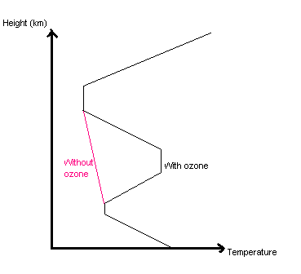

[ 6 points]
7. How would the seasonal cycle of temperature and the length of the day change if the axis of rotation of the earth
- had no tilt? (perpendicular to the plane of the Earth’s orbit) Explain.
There would be no seasonal variation. Every latitude would have 12 hours of daylight.

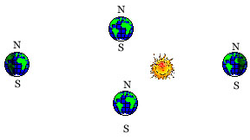
- were tilted all the way to the horizontal? (parallel to the plane of the Earth’s orbit) Explain.
Seasonal variation would be extreme. At winter solstice in the northern hemisphere, the length of the day would be 0 hours. At summer solstice (summer in the northern hemisphere) the day would be 24 hours long. At equinox, all latitudes would experience 12 hours of day and 12 hours of night. Note that both poles would experience both summer and winter during the course of a year.

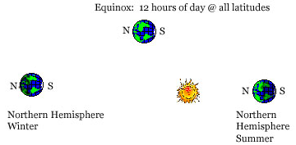
[ 8 points]

