Name:_____________________________________ Section: ________ TA: Celeste / Sarah / Ken

ATM S 101 HOMEWORK 5. Winter 2004
Due Thursday March 4th in class.

1. a) Why do we have a three-cell circulation in the troposphere instead of just one cell?

b) Are the strongest winds E-W or N-S? Explain why.

_____________________________________________________________________________________[6 points]

2. In the following map we show the fronts associated to a midlatitude cyclone.:
a) In the map:
i) Label the types of fronts
ii) Mark the position of the low-pressure center with an “L”.
iii) Shade in green the regions where you would expect precipitation
b) Over the next day, the midlatitude cyclone will move towards the east into the Atlantic Ocean at a speed of 15 m/s (or 54 km/h). Assuming that this map is for 9am on Feb. 29, 2004 and that the cyclone moves with its shape unchanged, calculate the approximate times at which the fronts that go over St. Louis pass overhead.
c) At the times found in part b, describe:
i) the changes in temperature
ii) the changes in pressure
iii) the changes in wind direction
iv) changes in sky conditions (cloudiness)
d) Approximately at what times would you expect precipitation on St. Louis?

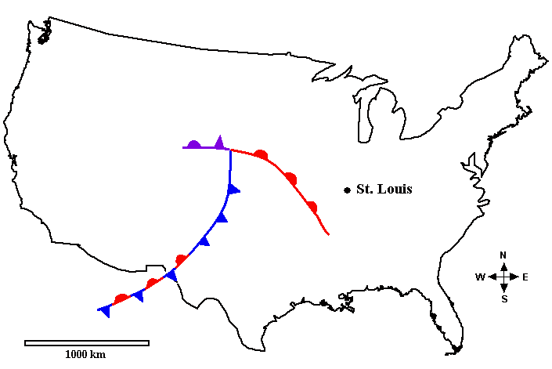

_____________________________________________________________________________________[14 points]

