ATM S 101 HOMEWORK 5 Solution. Winter 2004

1. a) Why do we have a three-cell circulation in the troposphere instead of just one cell?
The main reason is that the Earth rotates. Because of this and angular momentum conservation, air carried polewards by the Hadley circulation develops a strong westerly component in the upper troposphere (jet streams). The strong vertical shear (difference between the near surface and upper level winds) associated to the jet streams becomes unstable and causes the Hadley circulation to break down into three cells.

b) Are the strongest winds E-W or N-S? Explain why.
Temperature differences between the equator and poles lead to pressure differences both aloft and at the surface. These N-S pressure differences would tend to cause N-S winds, but the coriolis force turns the wind to the right in the northern hemisphere and to the left in the southern hemisphere. This causes the wind to blow E-W in order to achieve geostrophic balance between the pressure gradient force and the coriolis force.

_____________________________________________________________________________________[6 points]

2. In the following map we show the fronts associated to a midlatitude cyclone.:
a) In the map:
i) Label the types of fronts
ii) Mark the position of the low-pressure center with an “L”.
iii) Shade in green the regions where you would expect precipitation
b) Over the next day, the midlatitude cyclone will move towards the east into the Atlantic Ocean at a speed of 15 m/s (or 54 km/h). Assuming that this map is for 9am on Feb. 29, 2004 and that the cyclone moves with its shape unchanged, calculate the approximate times at which the fronts that go over St. Louis pass overhead.

The warm front is about 375km from St. Louis. 375 km / 54 km per hour is about 7 hours.
The warm front will cross St. Louis at about 4pm.
The cold front is about 900km from St. Louis. 900 km / 54 km per hour is 16.67. The cold front will cross St. Louis at approximately 1:40 am on March 1st.
The other fronts don’t cross St. Louis.
c) At the times found in part b, describe:
i) the changes in temperature
ii) the changes in pressure
iii) the changes in wind direction
iv) changes in sky conditions (cloudiness)

 | Warm Front Passes | Cold Front Passing
Changes in temperature | Temperature increases | Temperature decreases
Changes in pressure | Falling pressure levels off as the front passes. | Pressure falls to minimum at passing, then rises steadily
Changes in wind direction | S/SE changes to S/SW | SW change to NW winds
Changes in sky conditions | Stratus clouds before and during, then clearing with scattered Sc. | Ci, Cs changing to Cb, then Cu after passing

d) Approximately at what times would you expect precipitation on St. Louis?

Before the warm front, and around the time that the cold front passes. A wide range of times were accepted for this answer.

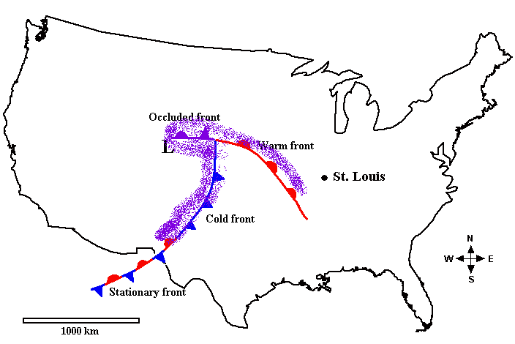
* Rainfall indicated in purple.

_____________________________________________________________________________________[14 points]

